Figures from class code

Warm up exercise 1. Line 23

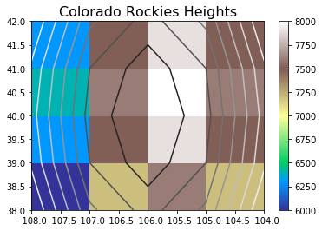

Line 31

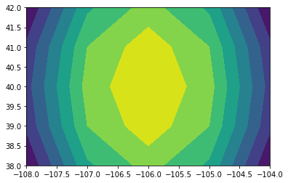

2/27/2019 Exercises

Exercise 1: Line 320

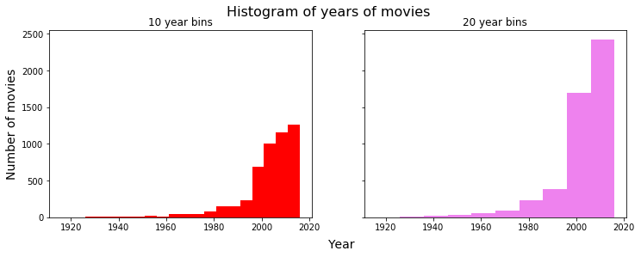

Exercise 2: Line 343

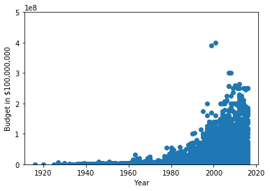

Exercise 3: Line 365

